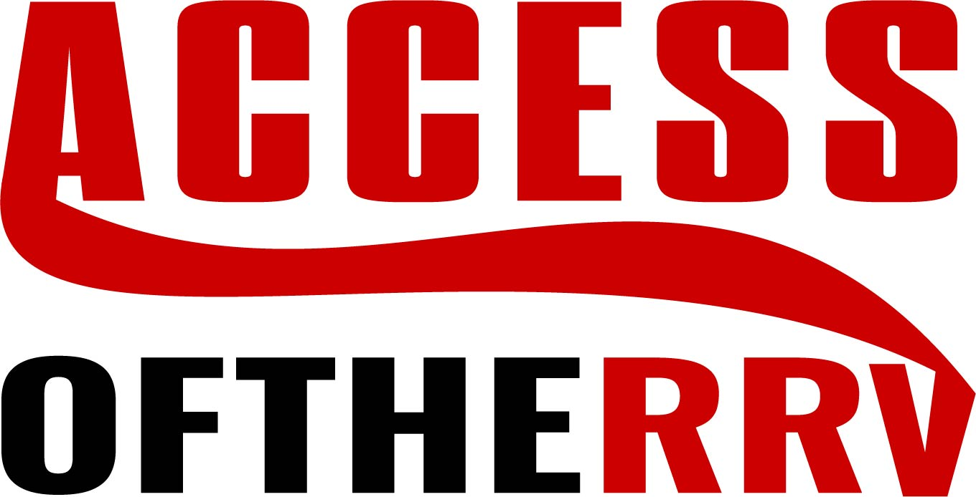

JOB DESCRIPTION
Job Title: Case Manager
Program: Services
Reports to: Program Manager
At-Will: All employment with the agency is at-will employment. Employment is on an at-will basis, subject to termination at any time at the will of either party, with or without cause.
MISSION STATEMENT
To provide care and to support children and adults in their right to lead, dignified, independent lives in the community.

SUMMARY
Coordination of services for individuals who have developmental, mental illness, and/or behavioral disabilities toward the end of assisting each person in living as independently as possible.

EDUCATION AND EXPERIENCE
- Bachelor’s degree (B.A., B.S.) in a human services field (example: social work, psychology, sociology, special education) from a regionally accredited university plus one year of direct care work experience (equivalent to 2080 hours) with consumers with developmental disabilities or;
- a two-year degree in the human services field plus two years of work experience (equivalent to 4160 hours) with consumers with developmental disabilities or;
- must have a diploma in a field related to human services from an accredited postsecondary institution and three years of full-time work experience (equivalent to 6240 hours) with consumers with developmental disabilities; or

Employment is contingent upon providing agency evidence of degree in related area as well as clear background checks.

JOB RESPONSIBILITIES
Evaluations:
• Completing direct report performance reviews
• Conducting site reviews as directed by the Program Manager
- Complying with all agency policies regarding EEO/AA and HIPAA

Supervisory and Administrative Responsibilities:
• Performing all of the responsibilities of the
Direct Care Professional position as is necessary (including direct client supervision)
• Directly supervising Direct Care Professionals including, but not limited to: directing work, conducting performance reviews, rewarding and disciplining employees, addressing complaints, and resolving conflicts.
• Accurate and timely response to information requests from outside agencies or individuals as appropriate
• Attendance and participation in staff meetings
• Regularly reporting to the Program Manager as to the current status of each client.
• Direct Care Professional scheduling, monitoring of time and attendance, etc.
- Other duties, as assigned

Program Responsibilities:
• Positive interactions with clients, guardians, client
families, representatives of other agencies, and other persons with whom
clients interact
- Admission and orientation of new clients
• Development and maintenance of the client paperwork including, but not limited to: goal/objective writing, observation of program implementation, ensuring proper documentation, and service recommendations
• Conducting and coordinating client reviews, team meetings, and site meetings, as is necessary or determined by the Program Manager
• Preparation of client transfer and discharge summaries
• Compliance with state and local licensing regulations
• Effective implementation of behavioral plans, if applicable
• Properly acting upon, documenting, and distributing Incident Reports
• Other duties, as assigned

Team:
• Supports and participates in common teamwork; cooperates and works
together with supervisors and co-workers
• Uses tactful, appropriate and professional communication
• Follows up with supervisor as appropriate regarding concerns and
complaints
• Promotes positive relations among agency employees
• Maintains confidentiality relating to all agency related data and matters
• Shall be capable of relating to individuals at various levels; as unique
situations present themselves, the incumbent must be sensitive to agency
needs, employee goodwill and public image

Medical and Health Responsibilities:
• Oversight, coordination, and proper
documentation of all client health, medical, and psychiatric care
• Coordination of referrals to consultants
• Other duties, as assigned
Financial Responsibilities:
• Maintaining accurate financial records for each client on a monthly basis, if applicable
• Other duties, as assigned

On-Call Responsibilities:
• Will be compensated for performing On-Call duties when assigned

Training Responsibilities:
- Case Manager shall annually complete required training.

JOB PHYSICAL DESCRIPTIONS:
Case Manager may be required to meet the following required physical demands of this position:
- Some work environment conditions are indoor office work. This position is required to sit at a desk and write or use computer and speak on telephone. The setting is normal office sounds (i.e.: phones ringing, printers, conversations and intercom) with varying indoor climates.
- Position also includes off-site client environments that vary from indoor to outdoor conditions depending on client needs and seasonal weather. Some sites are very quiet and others are very loud. Shall meet the following required physical demands of this position: Stand, walk, run, climb stairs, sit, use hands and fingers, kneel, crouch, physically restrain (when directed by supervisor), talk and hear, taste and smell. (Some transferring or lifting of clients may be required.) Close and distant vision is required.
- Case Manager is required to provide evidence of a current driver’s license, current auto insurance, and the use of a running insured car.

The above job description has been explained to me and I understand the responsibilities, requirements and descriptions of this position.

Signature of employee Date

