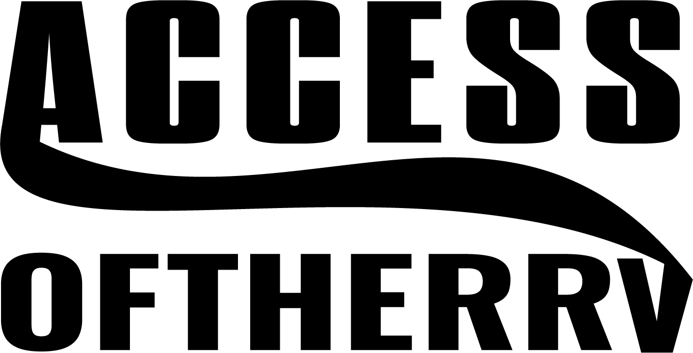

JOB DESCRIPTION
Job Title: Direct Care Professional
Program: Services
Status: Full-time employees:
-employees regularly scheduled 36 or more hours per week and designated “full-time benefited”
Variable Part-time Employees:
-employees regularly scheduled 29 hours or less per week and are designated “variable part-time”
-employees regularly scheduled 30 or more hours per week, eligible for health insurance under Affordable Care Act (ACA) law.
Reports to: Case Manager
At Will All employment with the agency is at-will employment. Employment is on
Employment: an at will basis, subject to termination at any time at the will of either party, with or without cause.

SUMMARY
Assist adults and children who have developmental, mental health, and/or behavioral concerns in achieving maximal quality of life and independence. The Direct Care Professional has a flexible schedule and is available to meet bi-weekly with their Case Manager to plan his/her site schedules.

DIRECT CARE PROFESSIONAL RESPONSIBILITIES
- Maintain tactful and appropriate communication (i.e., respectful and positive) with agency clients, supervisors and co-workers, as well as client families/guardians, representatives of other agencies, and other persons whom clients interact. Supports and participates in common teamwork; cooperates and works together with supervisors and co-workers. The Direct Care Professional must be sensitive to agency needs, employee goodwill and public image
- Maintain high standard of client safety at all times
- Teach client daily living skills. Client driven objectives and goals are understood and implemented by Direct Care Professionals as directed by the Case Manager (agency supervisors and directors)
- Be present for all scheduled meetings at appropriate date and time
- Correctly implement emergency use of controlled procedures when applicable and follow client behavior plans as written
- Complete all client positive support plans as required by the Case Manager (agency supervisors and directors)
- Document accurately (write) and complete all required information at client sites as directed by Case Manager (agency supervisors and directors), including reporting incidents
- Upon completion of the Access medication administration training, accurately report, chart, and administer client medications if applicable
- Assist client with any and all appointments, therapies, regimens and emergencies as directed by the Case Manager (agency supervisors and directors)
- Be responsible for client’s household budget, assisting with checkbook management and documenting client expenditures as appropriate
- Be trained at numerous sites and be available on an on-call or scheduled basis to work hours requested by their Case Manager each week. (Full time hours to include overnight and weekends as needed)
- Be responsible to meet on a regular basis with their Case Manager
- Provide their Case Manager a telephone number, cell phone number, and e-mail address if available so as to facilitate availability for scheduling
- Be responsible to notify their Case Manager of upcoming conflicts two weeks prior to the anticipated schedule conflict and follow Access’ request for time off policies.
- Be responsible for assisting with activities of daily living which includes but not limited to: cooking/meal preparation, cleaning, transporting clients to community events.
- Be responsible for properly using Access’ Time and Attendance programs.

OTHER JOB REQUIREMENTS

- Direct Care Professional shall be required to read and write, compute simple math problems, comprehend reports, correspondence, and verbal communications, and cope and/or deal with or problem solve client problems in standardized situations
- Attendance: Direct Care Professional shall maintain regular and acceptable attendance as scheduled and be punctual and be available to work weekends/holidays as needed.
- Requests for Time Off: The Direct Care Professional is required to fill out the appropriate paperwork (“Request for Time Off” form) with the signature of their replacement staff and submit it to their supervisor in a timely manner.
- Training: shall annually complete the required training.

TEAM
- Supports and participates in common teamwork; cooperates and works together with supervisors and co-workers
- Uses tactful, appropriate communication in sensitive and emotional situations
- Follows up with supervisor as appropriate regarding concerns and complaints
- Promotes positive relations among agency employees
- Maintains confidentiality relating to all agency related data and matters
- Shall be capable of relating to individuals at various levels; as unique situations present themselves; the incumbent must be sensitive to agency needs, employee goodwill and public image

JOB PHYSICAL DESCRIPTIONS
  - Direct Care Professional shall meet the following required physical demands of this position: Stand, walk, run, climb stairs, sit, use hands, and fingers, kneel, crouch, physically restrain (when directed by supervisor), talk and hear, taste and smell. Some transferring or lifting of clients may be required. Close and distant vision is required.
  - The work environment conditions vary from indoor to outdoor conditions depending on client needs and seasonal weather. Some sites are very quiet, and others are very loud.
  - Direct Care Professional is required to provide evidence of a current driver’s license, current auto insurance, and the use of a running insured car.

The above job description has been explained to me and I understand the responsibilities, requirements, and descriptions of this position.

Signature Date

